Building Navigation Assistance Project

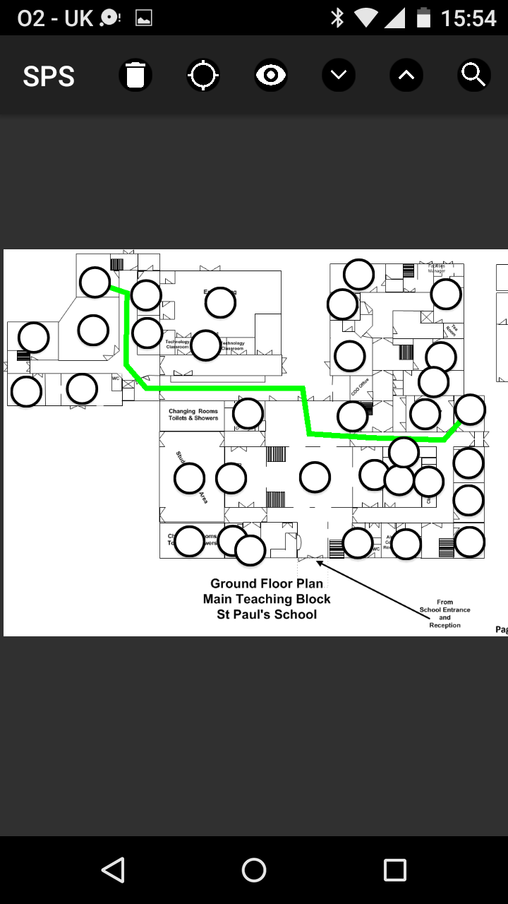

Oliver Vecchini

AQA Computer Science A-Level Non-Exam Assessment

Supervised by Mr. Richard Barker